Paving Streets - Part One
by George Huckaby & Charles Hepperle

December 15, 2004
1. BACKGROUND

This lesson is written in conjunction with lessons on prototype Street Railway Track and the installation of HO scale ORR Street Railway Track. The lesson will cover cobblestone/brick/Belgian block paving and concrete in streets where street railway tracks are located.

In Part One, we will concentrate on paving streets using plastic sections readily available to the modeler such as Walthers Brick and Concrete Street Systems, Smalltown USA Sidewalks, Plastruct and Evergreen Styrene sheets and strips.

In Part Two, we will discuss the use of Durham's Water Putty for the creation of sidewalks, asphalt and concrete roads.

Note 1: Before we get started, it is essential that you test all of your trackwork to be sure that it operates perfectly. Once you have added the paving, it is extremely difficult to make track repairs and corrections.

2. PROTOTYPE PAVING

Before paving a street, you should decide which era that you need to model. Early street railway track was in the center of a dirt or mud road. Sprinkler cars were used to keep the dust down in the heat of the summer. At the turn of the century, Belgian block and cobblestones ruled the paving scene. For a while, concrete was used and finally asphalt. Now in the year 2003, the renewed track areas in cities such as Philadelphia, San Francisco and Toronto are being paved with concrete. The track area includes the area between the rails, about two to three feet either side of the rails and in the case of double track areas, the entire "devil strip" between the tracks. Study photos of your favorite area before paving. You will notice things that you never noticed before.

3. PAVING MODEL STREETS - GENERAL

The most fundamental point is to keep whatever paving surface is used slightly below the level of the rails. Track must be cleaned once in awhile and a nice road can be ruined in seconds with a bright boy cleaner. We will be using ORR Girder Rail, which has a web height of .100" (Code 100). ORR turnouts and crossing have web heights ranging from .100" (2.56 mm) to .108" (2.8mm) so any paving should not be higher than .08 -. 09 inches from top of the ties.

Using another module of the Southern California Traction Club, we will be doing a red brick street as existed on Chestnut Street in Philadelphia prior to the abandonment of streetcar service in the mid-1950s. We will be doing some concrete and some cobblestone. For brick, cobblestone, Belgian block and concrete streets, we use generally use plastic sheet, for asphalt and macadam roads, we use the Durham's Water Putty, discussed in Part Two.

4. CITY SIDEWALK INSTALLATION

For city sidewalk modules, we recommend that sidewalks be installed prior to the paving of the street. We will be using plastic sidewalk stock for all sidewalks, using Smalltown USA #699-7000 City Sidewalks along with some of the Walthers Sidewalks contained in their Brick Streets and/or Concrete Streets Kits. After laying out the location of sidewalks, driveway entrances and curbing, obtain some Evergreen Strip styrene #149 (.040" by .250") and #167 (.080 by 156").

In the photo of the brick street under construction, the sidewalks contained in the Walthers Brick Street System Kits were used. They were doubled on the left side of the photo for a more realistically sized sidewalk where there were steps to the row homes that will be located there.

Using Plastruct cement, fasten the #167 strips to the underside rear of the sidewalks, flush with the rear edge and fasten the #149 strips to the front of the sidewalk (the side adjacent to the street) in such a manner that 1/2 of the strip, or .125" extends past the curb. This will ensure that the minimum thickness of the paving material will be .040".

This will also require all structures to be mounted on some type of base that is at least .040" thick so that the front of the building matches the height of the rear of the sidewalks. This will allow the structures to be more firmly affixed to the module and prevent light leaks should the bottom floors be illuminated later. These are some of the reasons why we always have our structures and driveways selected early in the module development process.

After installation, wet sand the surface with 240 grit wet-or-dry paper then wipe off the residue with a damp rag.

5. COBBLESTONE, BELGIAN BLOCK AND BRICK STREETS

The method for paving these streets is to acquire some plastic brick sheets; note the thickness, and acquire some styrene strips with the appropriate thickness so that the combined thickness of the strips and the sheet does not exceed .080". So if the brick sheet is .020", make sure that the strips are no higher than .060". So far, we have used the Walthers Brick Street System sheets, which are .060" thick, Vollmer 6028 Brick Sheet, which are .050" thick and Plastruct #91605 Rough Brick, which was only .020" thick. But for the most part we use the Walthers Brick Street Systems, 933-9139 and 933-3156 (added straight sections only).

We prefer to use the Walthers Brick and Concrete Street Systems for two reasons. First, the three tabs on the bottom of each section produce a realistic street crown. Second, at the right side of each concrete or brick section (shown below), the top of the street surface will be .130" from the surface of the module. Since Orr Girder Rail is has a .100" web height and the Clover House ties are .06 thick, these sections will normally be .030" from the top of the rails, allowing for track cleaning without disturbing any painted surfaces.

a. For straight street and track sections, we used the brick street sections (approximately 3.5" by 2.75") from the Walthers #933-3139 Brick Street System as shown below:
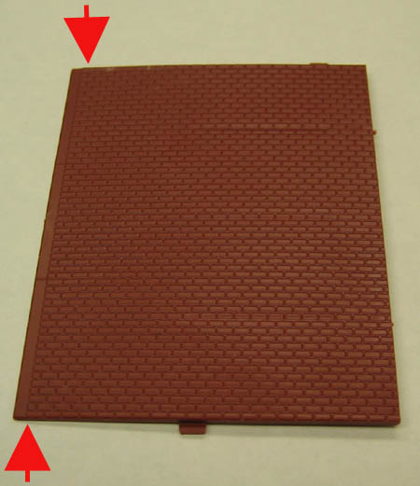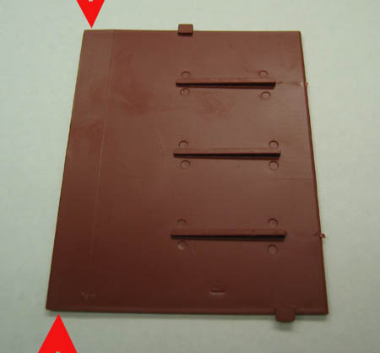

Two sections placed in mirror fashion will produce a street 38.5' to 40' wide, depending on whether the gutter portion on the curbside are used. We normally remove them since they were not prototypical in the areas that we referenced for our modeling. The red arrows are pointing to edge intended for the curbside. The bottom is tapered to allow for placement next to the curb. Also note the tabs on the underside and the three bars, which helps to ensure a crown on the street. When installing the street section, we cut the sections leaving the curbside intact and then we cut the portion for between the rails from the remnant. In some cases we can get two sections of brick for between the rails from one section.

When the sections are placed together, scraps of plastic are used under each joint to give strength to the joint when plastic weld adhesive is used. Below, six sections of this paving material have been used on this 25' wide street so far. The portions cut away for the areas outside of the track were used to fill the areas between the rails.
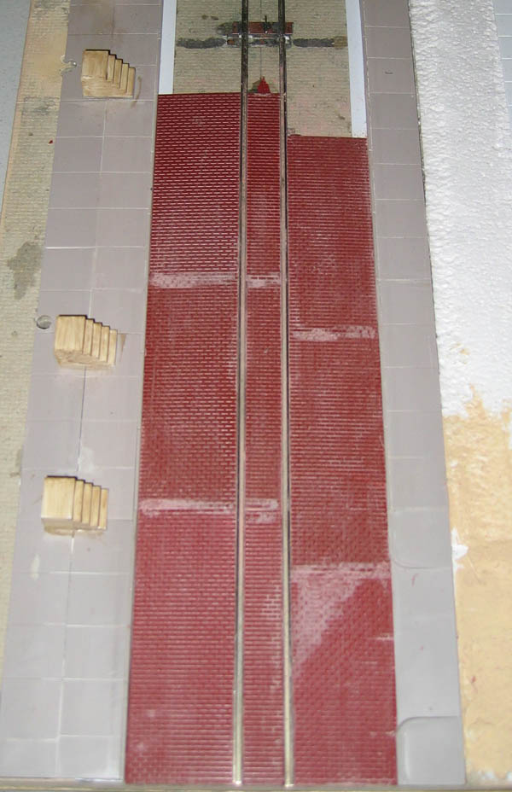

The light areas are the joints between sections. The joints are to be hidden as much as practical. Plastic Weld cement has been used at those joints and after the cement is dry, the joints have been sanded.

b. For curved track, there is another problem. The areas outside of the rails are paved the same as straight street sections as the bricks, blocks or cobblestones are normally placed perpendicular to the curbs. However, any bricks, blocks or cobblestones between the rails, or devil strips between the tracks on double track area are placed tangent to the curve. For these areas we use thin brick plastic sheet such as provided by Plastruct.

Cut a strip of the Plastruct brick sheet about six inches long and four scale feet wide. Using an Xacto knife, slice each line of brick for almost three of the four feet of width. You do not have to cut all the way through. As you do this you will note that the brick will begin to curve slightly.

Since this sheet is about .020" thick, we will need to fill the area between the rails with styrene no thicker than .060". Once this is done the brick can be fit into the curve and fastened to the styrene base with Plastic Weld cement.

c. For peculiar shaped areas, we use the same Walthers Brick Street sections and we have a proven method of installation. As an illustration, we are going to pave the area indicated by the red arrow in the photo below:
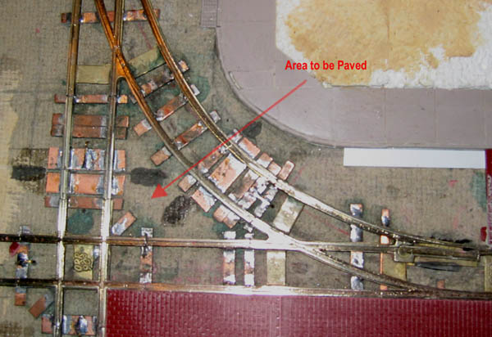

1) First, we will take some 1/8" Styrofoam and cut to cover the entire area to be paved;
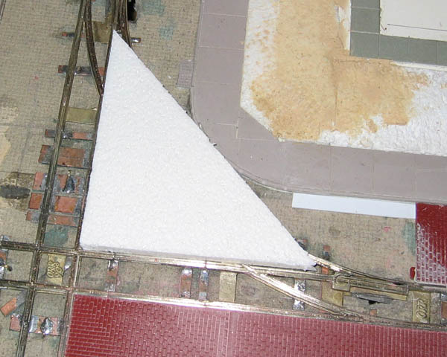

2) Using your fingers or another blunt object, press down gently but firmly on the Styrofoam along the borders of the area to be paved until there is an impression of the rails, curbs or other significant paving borders in the bottom of the Styrofoam.
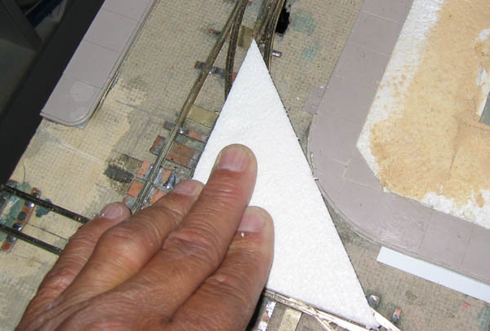

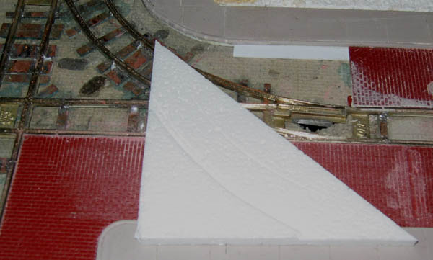

3) Cut carefully along the impressions and test the pattern for fit. We cut a little larger than the pattern and trim later to ensure that we do not make an undersize cut.
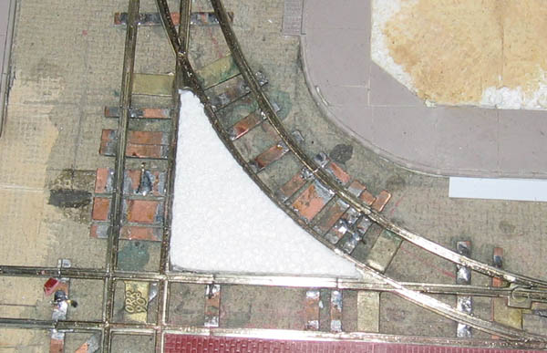

4) Once the Styrofoam filler fits in the area, use it as a pattern to cut the paving material. Use the pattern to cut the Walthers brick sheet and after a little final sanding, the piece literally "drops" into place. Use a sanding stick for the final sanding of the edges to ensure a precise fit. Once the fit is achieved, use some styrene to ensure the correct level of the paving material relative to the top of the railhead.
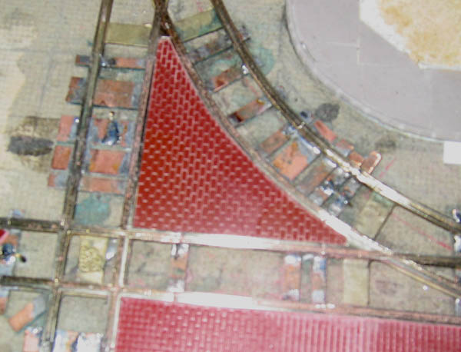

d. Painting the brick sheet

Color is a very subjective subject. Feel free to vary the choice of colors and the amount applied to suit your situation. We have found that oil-base Floquil paints adhere much better and are more durable than water-based paints. While it might be possible to use spray cans, much more control can be achieved by using an airbrush. When spraying, try to avoid having the exact same shade over the entire area. By misting on various colors, you can apply different amounts to different areas to keep it from looking too uniform. Not shown is additional painting to simulate crosswalks, dirt, oil drips, skid marks, cracks and repaired areas.

Note 2: Even if this street is to remain a brick street, the red will have to be "toned down" a bit.

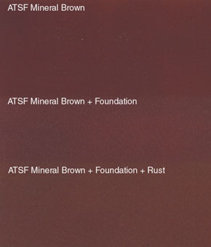

Painting of the brick street will be accomplished in a series of steps with the results appearing as in the above illustration as follows:

1) Carefully mask the running rail of the track and the curbs/sidewalks.
2) Spray Floquil ATSF Mineral Brown [110179] over the brick until the red is almost invisible.
3) Then lightly spray (mist) the following colors in order:
a) Floquil Foundation [110084]
b)Floquil Rust [110073]

If this were to be a cobblestone street, the red brick would also have to be painted. Shown below left is a close up photograph of a single cobblestone removed from the 4800-5200 blocks of Girard Avenue (Philadelphia) during the 2002-2003 light rail reconstruction project. Note how many different colors are actually contained in a cobblestone. Construction of cobblestone streets normally differ from brick streets in that the cobblestones are many different lengths while maintaining similar widths while bricks are usually uniform sizes. In HO scale, this is not readily noticeable after painting is completed.

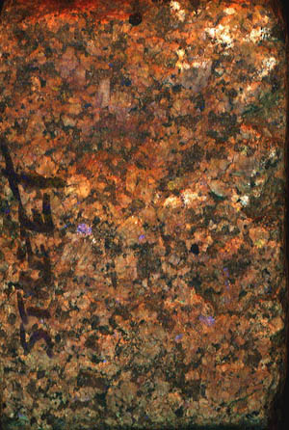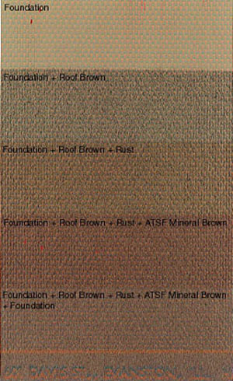

Painting will be accomplished in a series of steps with the results appearing as in the above right illustration as follows:

1) Carefully mask the running rail of the track.
2) Spray Floquil Foundation [110084] over the brick until the red is almost invisible.
3) Then lightly spray (mist) the following colors in order:
a) Floquil Roof Brown [110070]
b) Floquil Rust [110073]
c) Floquil ATSF Mineral Brown [110179]
d) Floquil Foundation [110084]

6. CONCRETE STREETS

For a concrete street, we normally use the same method used with the Walthers Brick Street system can be used by employing the Walthers #933-3138 or 933-3155 Concrete Streets Kits. Using these Walthers sections is a lot less messy than using the Durhams' Water Putty, which we now use exclusively for asphalt and macadam roads. Similar sections, the same size as the brick sections, can be installed in the same manner. One difference should be mentioned. The cracks between the sections will not be eliminated when the sections are joined. After air brushing with different grays and concrete colors, these cracks will be filled with dark gray glossy paint to simulate tar. The sections will be scored for additional expansion joints and natural cracks. Note the sections in the photo below. They have not yet been painted:

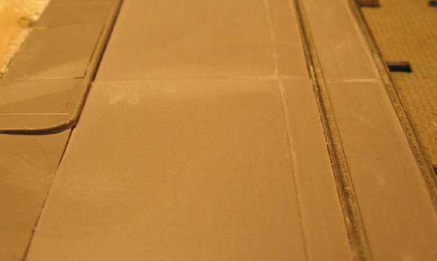

As in the case of the brick (cobblestone) street in section 5, each section produced not only the roadway from the curb to the track but also the paving between the rails.

After installation, wet sand the surface with 240 grit wet-or-dry paper then wipe off the residue with a damp rag.

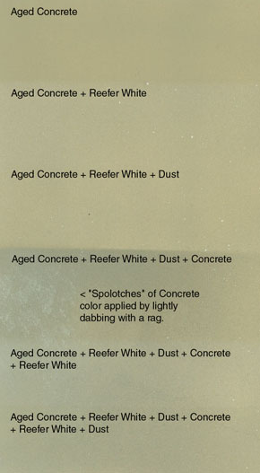

a. Painting the concrete street
Painting will be accomplished in a series of steps with the results appearing as in the above illustration as follows:

1) Carefully mask the running rail of the track and the curbs/sidewalks.
2) Spray Floquil Aged Concrete [110016] over the styrene.
3) Then, lightly spray (mist) the following colors:
a) Floquil Reefer White [110011]
b) Floquil Dust [110006]
c) Floquil Concrete [110082]
d) Floquil Reefer White [110011]
e) Floquil Dust {110006]

Note 3: The purpose of misting on several colors, then repeating, is to get a multitude of tiny specks of colors to help simulate the texture of concrete. Although at HO scale it actually would be very smooth, our minds consider it to be rough and the specks help create that illusion on our models.

Note 4: Concrete comes in many colors. Older concrete looks more tan, as shown above. Newer concrete appears more gray, especially light gray. For this you might want to start with your own custom mix of Reefer White [110011] and a little Reefer Gray [110012].

With a piece of cardstock as a mask, spray various sections with differing amounts of color to simulate concrete that was poured at different times. You can also add "splotches" by using a rag dampened with a little Dio-Sol then dipped in a little bit of Concrete color. Dab the rag so only a small amount of paint is transferred to the surface. Use this technique with various colors to make your streets and sidewalks look more realistic.

7. ASPHALT STREETS

As of the date of this lesson, we are using Durhams Water Putty for simulating asphalt-paved streets, although in the past, we have used Durham's for simulating concrete streets. This will be discussed in more detail in Part Two.

8. FOR MORE INFORMATION

If you desire to model street railways, review other lessons in the Trolleyville Schoolhouse, especially Parts 2 and 3 of the ORR TRACK lessons or visit the EAST Penn Traction Club web site at www.eastpenn.org. You can email us at orrtrack@customtraxx.com with any questions. When asking questions about proposed track plans, please provide all data, especially a scale drawing of the proposed plan, so that we can answer your questions as accurately as possible.

